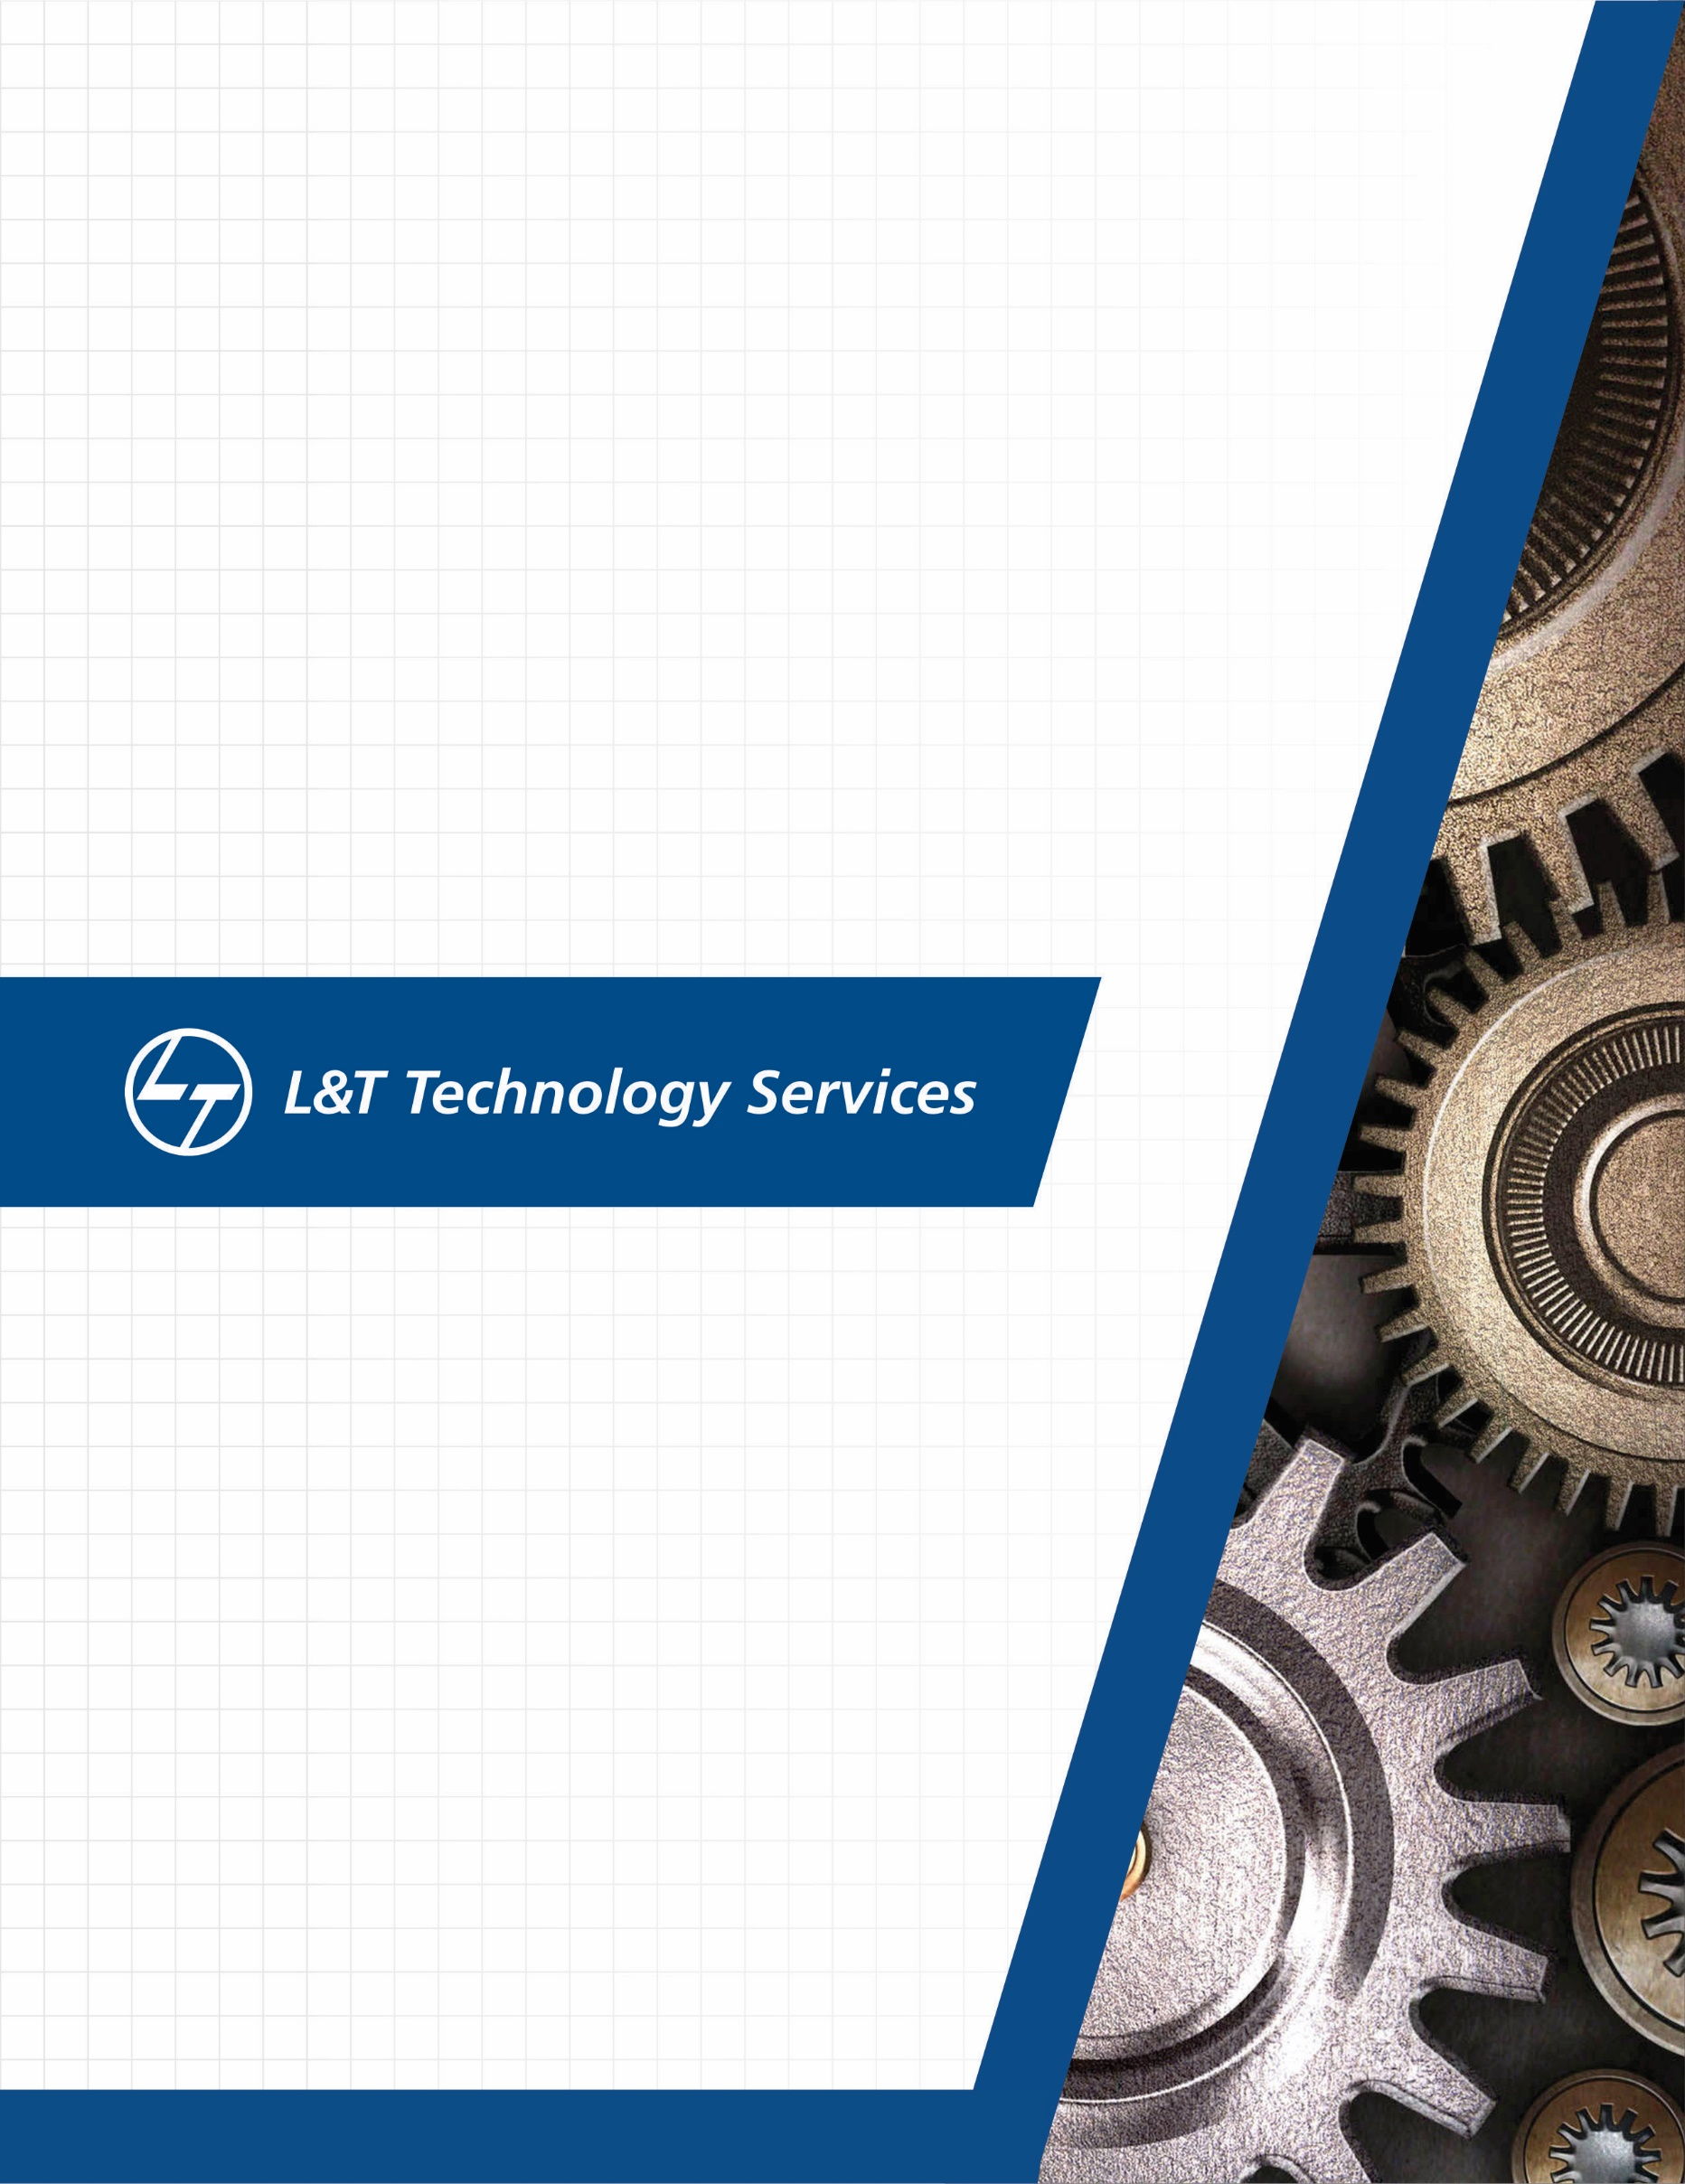./

Learning Report – Automotive Systems and Overview



|  |  |  |  |  |  |
| --- | --- | --- | --- | --- | --- |
| **Ver.Rel. No.** | **Release Date** | **Prepared. By** | **Reviewed By** | **To be approved By** | **Remarks/Revision Details** |
| 1 | 20.03.2021 | Sourav Dey |  |  |  |
|  |  | Santosh |  |  |  |
|  |  | Ravi |  |  |  |
|  |  | Sushma |  |  |  |
|  |  |  |  |  |  |

**Document History**

Table of Contents

Table of Figures 3

Table of Tables 4

ACTIVITY 1: SYSTEM/ SOFTWARE DEVELOPMENT 4

**INTRODUCTION** 4

**MY PRODUCT: “Name ”** 6

**SWOT ANALYSIS** 7

**REQUIREMENTS** 7

**DESIGN** 8

HIGH LEVEL DESIGN 8

LOW LEVEL DESIGN 11

**TEST PLANS** 13

APPENDIX: 17

## Table of Figures

Figure 1 ACTIVITY DIAGRAM (HIGH LEVEL) ………………………………………………………………………………………………..….09

Figure 2 USE CASE DIAGRAM (LOW LEVEL)…………………………………………………………………………………………………….10

Figure 3 CLASS DIAGRAM (LOW LEVEL) …………………………………………………………………………………………………………11

Figure 4 TEST PALN………………………………………………………………………………………………………………………………………..12

Figure 5 GIT 16

Figure 6 GIT ISSUES 17

Figure 7 GIT COMMITS 1 18

Figure 8 GIT COMMIT 2 19

## Table of Tables

Table 3 REQUIREMENTS (HLR AND LLR) 06

Table 4 HIGH LEVEL TEST PLAN 15

Table 5 LOW LEVEL TEST PLAN 16

**INTRODUCTION:**

This document work towards Safety and some body

Heating, ventilation and air conditioning (HVAC) is the technology for indoor and automotive ambient comfort. HVAC facilitates in managing the pleasant climate inside the cabin by controlling the degree of hotness/coolness.

There were times when having an air conditioner in a car was considered one of the big features, but today air conditioners have become standard equipment even in entry-level automobiles. The desire for even more comfort and luxury has led to the development of the climate control system inside an automobile. The primary purpose of automatic climate control is to manage the temperature of a given area for the comfort of onboard passengers.

**Research and Literary Survey**

This document brings about a detailed work in some body control and safety application present in the modern-day cars. The modern-day car can be divided into few parts as given below:

1. Chassis
2. Powertrain
3. Body

Earlier generation cars mainly employed an air conditioner. However, it only cooled the cabin air. It was not capable to control the temperature of the air effectively; especially in winters. So, it caused discomfort to the occupants. To improve this situation, automotive engineers developed the second-generation HVAC systems for vehicles.

Manufacturer use this technology for achieving better vehicular environmental comfort.

The term HVAC means “Heating Ventilation and Air Conditioning”.

The different components present in a modern HVAC system is given below:

1. Compressor
2. Condenser
3. Receiver/ Dryer or Accumulator
4. Thermal Expansion valve
5. Evaporator

According to a comprehensive market analysis and industry forecast published by Allied Market Research, the automotive HVAC market is expected to experience a compound annual growth rate of 8.9 percent during the six-year period between 2016 to 2022—a projected $22.8 billion by 2022.

GMC SEIRRA

HVAC Module (Manual) – AC part only

User interface:

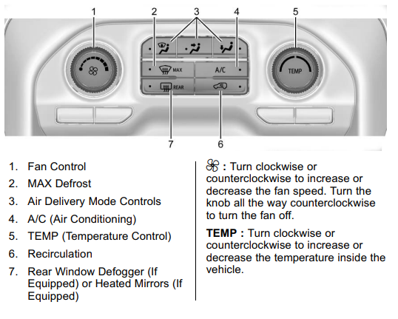

Classification:

Input:

1. Switches for human interface
2. Rotary Switches used in HVAC
3. Temp Sensor
4. Humidity Sensor

Switches for human interface:

* V series Rotary switch (3 position)
* AVH switches

Temperature Sensors:

* NTC: NTCLE203E3...SB0 – NTC Thermistor, 2-point radial leaded, Automotive Grade.

Features:

Operating temperature range: -55-degree C to + 150-degree C.

Maximum Dissipation: 100 mW

Response time: 7 secs

Resistance at 25-degree C: 2.06k to 30k

Accuracy between 25-degree C to 85-degree C: + or – 0.5-degree C

* RTD: HEL 700 Series – Thin film platinum RTDs

Features:

Operating temperature Range: -70 °C to 260 °C

Maximum Dissipation: < 15 mW (self-heating)

Operating current: 2 mA

Linearity (-40 °C to 125 °C): ±0.1% of full scale

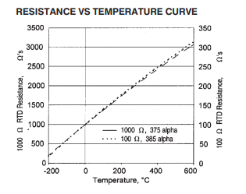

* **LM series: LM 35**

Features:

Operating temperature range: –55°Cto 150°C

Maximum dissipation:

Operating current: 10 mA

Power supply: 4V to 5.5V

Humidity Sensors:

* HDC1008:

Features:

Operating range: -20°C to 60 °C

Operating voltage: Nominal: 3V; Range: 2.7V to 5.5V

* HTU21D(F):

Features:

Operating range: -40 to +125 °C

Supply voltage: 3.8V

Power dissipation: 2.7uW

Algorithms:

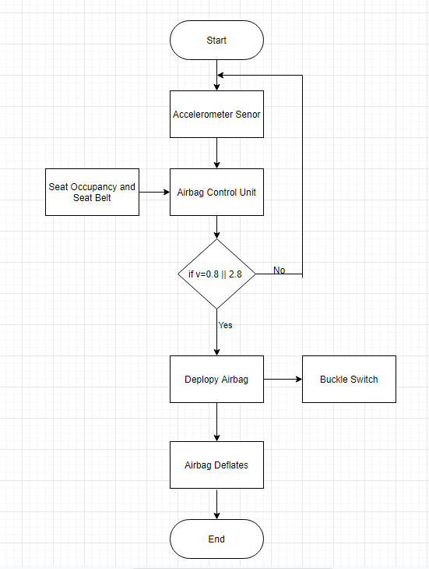

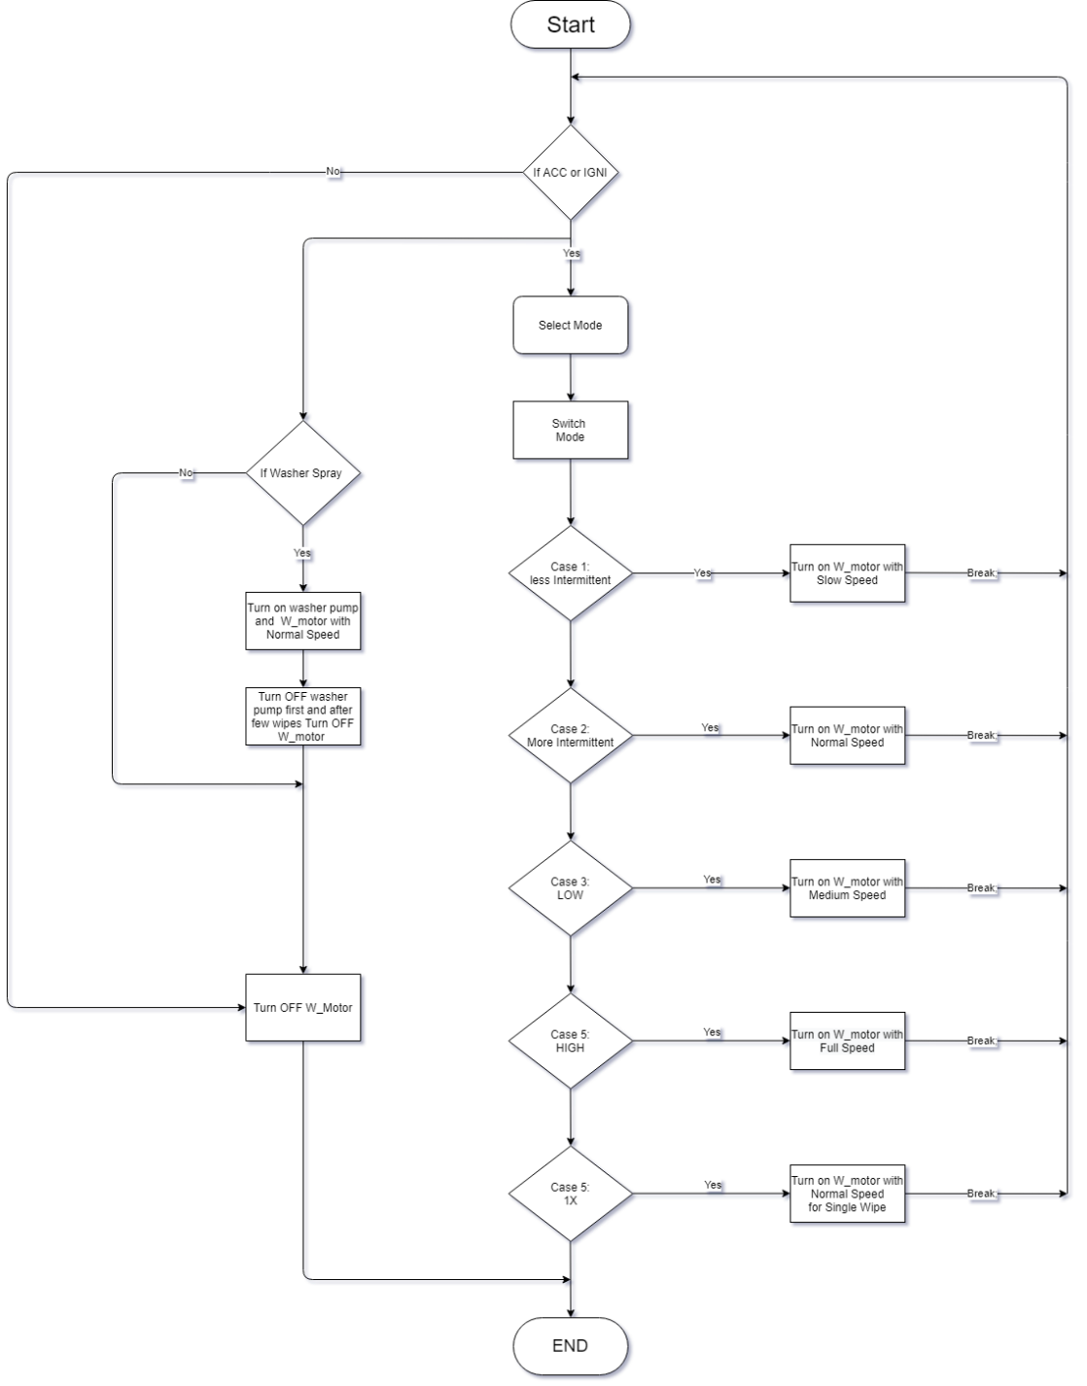

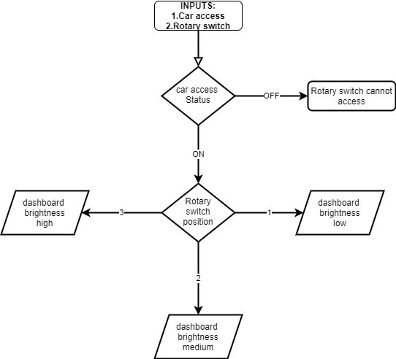

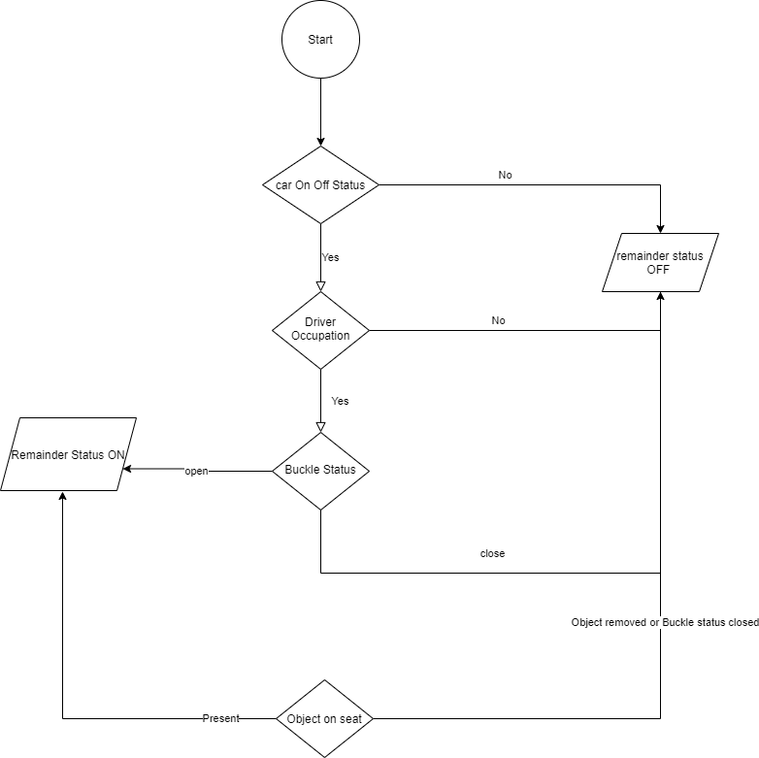

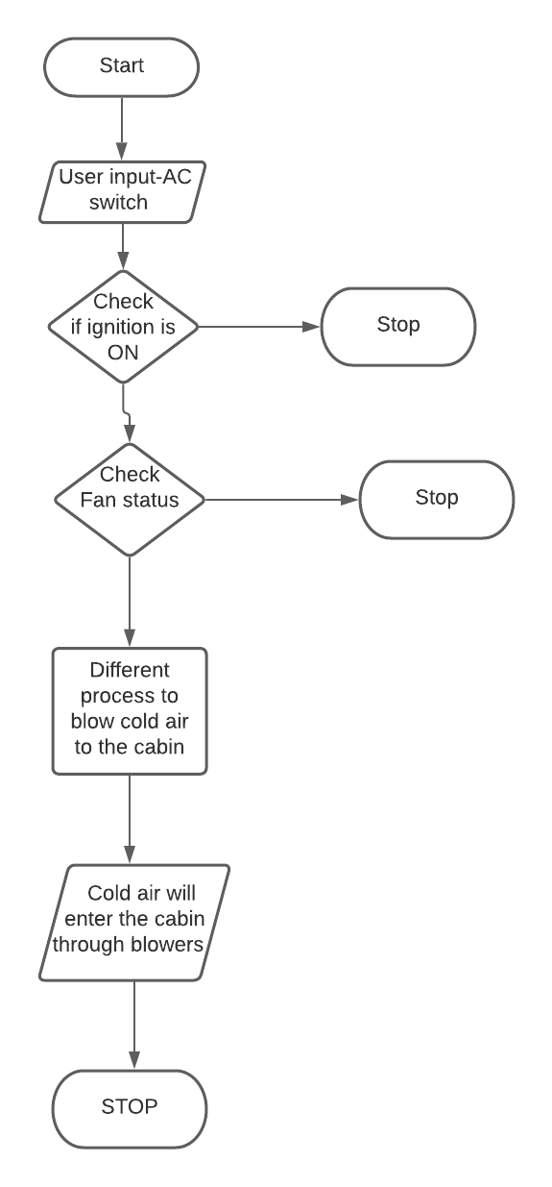

Fig: AC working

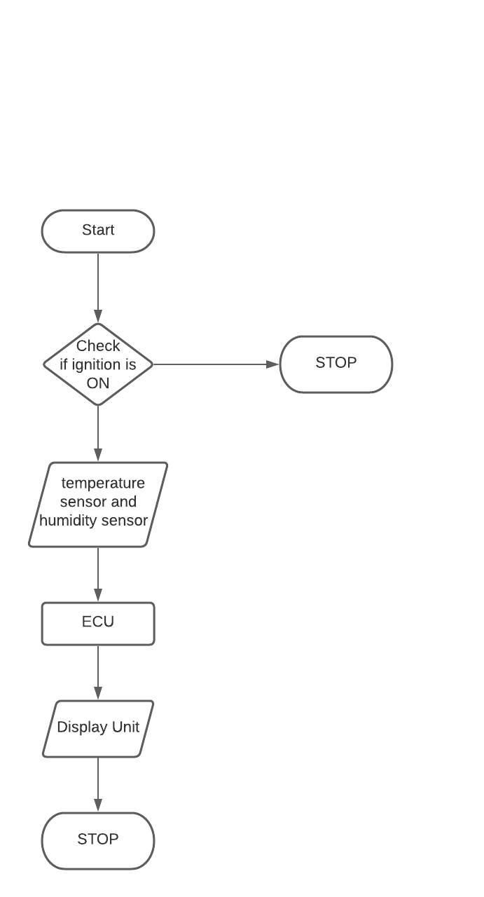

Fig: Calculation of Room temperature and humidity inside the cabin.

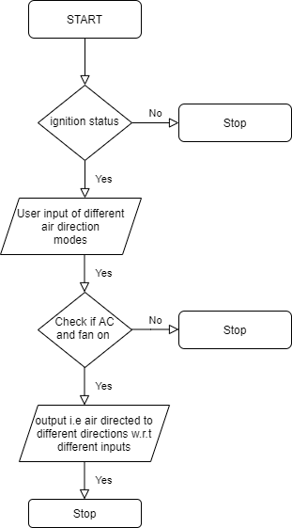

Fig: Algorithm for different modes of air blowers.

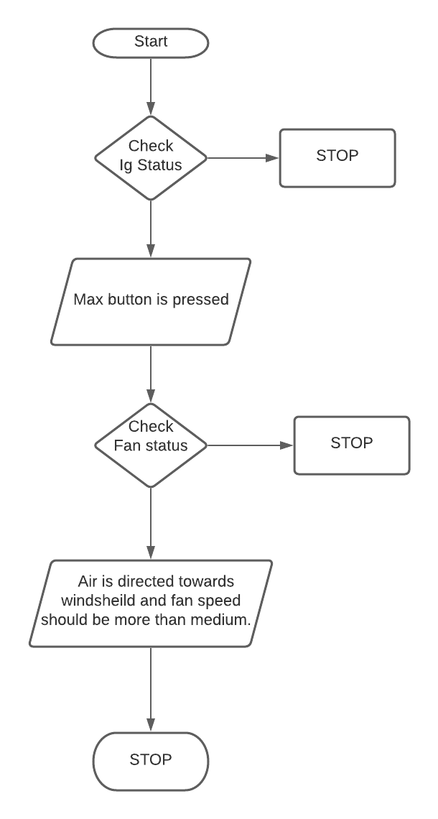

Fig: Algorithm for the usage of max button.

Output:

* The cooled air will reach the cabin through blowers.

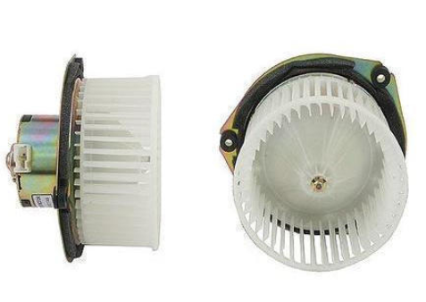

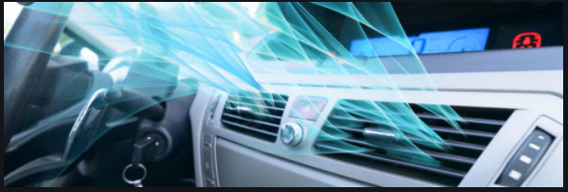

* The temperature and humidity of the car will be displayed in the dashboard.

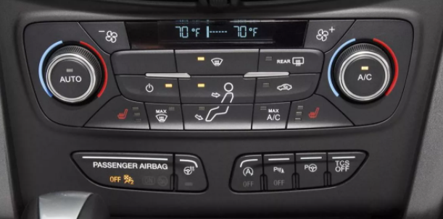

**FEATURE:**

The feature which I have selected is the HVAC module of GMC Seirra truck. This document covers only the working of AC part of total HVAC system. GMC Sierra has two types of HVAC system:

1. Manual HVAC
2. Automated HVAC

This document covers only the manual working of the HVAC system. In this module, the control of interface is given to the user i.e. the driver or the passenger must manually switch ON the AC button.

The AC would not work unless the fan of HVAC system is switched ON. There are three different modes to control the direction of the air inside the cabin.

Moreover, there is a recirculation button which cools the car as fast as possible.

The HVAC module also provides a “rear defogger” button that provides air (non-humid) to the rear wind shield. The operation of this button is to remove the fog created in the rear wind shield.

**SWOT:**

|  |  |
| --- | --- |
| **STRENGTH**   * To provide comfort to the driver and passengers by maintaining the temperature inside the cabin. * Less cost than manual HVAC. * Airbags prevent injuries among drivers and passengers in the event of a crash. * Airbags is effective to fully inflated in a short amount of time * **User friendly.** * **5 different modes of wipes.** * **Sufficiently removes rain water, snow, ice, washer liquid etc.** * Innovation and user friendly. * Durable and long lasting. * Easily available in market. * Good referral relationships with architects, complementary vendors and local realtors. * Safety of user * Helps in Airbag operations | **WEAKNESS**   * The driver or the passengers need to provide the modes to control the climate inside the car. (i.e. it is manual not automatic) * More fuel consumption. * Air bags do not replace the need for seat belts. Some people wearing no belt or only a lap belt have been hurt and killed by the deployment of the airbag. * Once the airbag is deployed it must be replaced by the consumer, which costs about $500-$2000. * **Doesn’t have automatic operation.** * **No other means of control than the wiper lever.** * Not established in a market where a variety of interior design options exist. * Challenges of the seasonality of the business. * Competitors can offer similar products quickly * Detects object as user * Driver negligence |
| **OPPERTUNITIES**   * Large market size in India. * Temperature conditions in subcontinent regions. * The market for airbag has been growing at a higher pace than that of automotive market due to increasing awareness towards passenger safety. * It can be expanded to automated system * Like using rain sensor system operates * automatic. * Interior Lights can be used in any vehicles like in bus, trucks, train etc. * Interior lights can be used in home appliances to pleasing environment. * Negligence of seat belt remainder should restrict the speed of vehicle. | **THREATS**   * Existence of strong competitor. * Sensor malfunction * Hardware Malfunction * Rising prices of materials and services * Designers being contracted up from the city * Changes in regulations can impact the business * **Motor failure.** * **Wiper blade damages.** * Active safety systems will overtake passive protection, such as airbags. These advanced systems can impose serious threats to airbag industry. |

**REQUIREMENTS:**

HIGH LEVEL REQUIREMENTS:

|  |  |
| --- | --- |
| BCM_AB_HLR_1 | Detection of Crash |
| BCM_AB_HLR_2 | Deployment of airbag |
| BCM_WP_HLR_3 | Wiper ON and OFF |
| BCM_WP_HLR_4 | Wiper Mode Control |
| BCM_WP_HLR_5 | Single wipe and several wipes |
| BCM_WP_HLR_6 | Spray windshield washer fluid and Activate the wipers. |
| BCM_SB_HLR_7 | System should remind the user to wear the seat belt. |
| BCM_HVAC_HLR_8 | When the driver or passenger turn on the AC and fan switch, then cool air must enter the cabin of the car through blowers. The ignition should be switched on. |
| BCM_HVAC_HLR_9 | Fan rotary switch must control the speed of air entering the cabin. |
| BCM_HVAC_HLR_10 | The temperature rotary switch must control the temperature of the air entering the cabin. |

LOW LEVEL REQUIREMENTS:

|  |  |
| --- | --- |
| Requirements | Description |
| BCM_AB_LLR_1 | Seat Occupancy- Using Pressure Sensor |
| BCM_AB_LLR_2 | Seatbelt - Using Seatbelt Warning Module |
| BCM_AB_LLR_3 | Seatbelt Tighten - Tighten the seat belt |
| BCM_WP_LLR_4 | Rotary switch to start and select wiper Mode. |
| BCM_WP_LLR_5 | Push Button to turn on the washer fluid pump. |
| BCM_WP_LLR_6 | Control wiper motor speed for different speed. |
| BCM_SB_LLR_7 | Vehicle Power On/Off status. |
| BCM_SB_LLR_8 | User Occupation on Seat. |
| BCM_SB_LLR_9 | Seat Belt Buckled Status. |
| BCM_IL_LLR_10 | Dashboard brightness increase/decrease by rotary button. |
| BCM_IL_LLR_11 | Reading lamps are ON when Doors are open or by manual switch. |
| BCM_IL_LLR_12 | Dome lamps are ON when Doors are open or by manual switch. |
| BCM_HVAC_LLR_13 | If AC is switched ON and fan is not switched ON then the AC should not work. |
| BCM_HVAC_LLR_14 | The temperature sensor present below and above the cabin will monitor the temperature and its output is current, which is send to ECU that will convert the current into equivalent temperature. This value is displayed in the dashboard. |
| BCM_HVAC_LLR_15 | The humidity sensor present in the cabin will calculate the humidity and the result will be displayed in the dashboard via ECU. |
| BCM_HVAC_LLR_16 | When the recirculation switch is pressed then the cabin of the car must get cool at a faster rate. Here the fan speed must increase and the temperature of the air must decrease. |
| BCM_HVAC_LLR_17 | Air delivery mode buttons present in the dashboard must start and stop the respective blowers in the respective directions. |
| BCM_HVAC_LLR_18 | When Rear window defogger button is pressed, humid less air must enter the cabin and the fog created in the rear window must be removed. Here the fan speed should also increase. It must run when the engine is on. |
| BCM_HVAC_LLR_19 | When the max button is pressed, air is directed towards the windshield and the fan runs at a higher speed if not above a medium fan speed. |

**TEST PLAN:**

High Level Test Plan:

|  |  |  |  |  |  |
| --- | --- | --- | --- | --- | --- |
| ID | Description | Input | Expected Output | Actual Output | Test Type |
| BCM_SB_HLR_01 | Vehicle On/Off Status | Ignition On | Display Power On | Display Power On |  |
| BCM_SB_HLR_02 | Seat Buckle should be working | Fasten seat belt | It should get buckled in. | Gets buckled in. |  |
| BCM_SB_HLR_03 | Seat belt Reminder should not indicate. | Fastening of seat belt. | No output on the display to indicate. | No output on the display to indicate. |  |
| BCM_IL_HLR_04 | Interior lights like dome and reading lights become on and brightness of instrumental panel become brighten | Dome switch, reading switch to ON and rotary switch | Dome Lamp and Reading Lamp should ON and brightness increases/decreases | Dome Lamp and Reading Lamp should ON and brightness increases/decreases |  |
| BCM_HVAC_HLR_05 | The AC should work after the ignition is ON and the fan status is ON | User input; switching ON the AC and fan button | Cool air must blow in the cabin through blowers. | Cool air must blow in the cabin through blowers |  |

Low Level Test Plan:

|  |  |  |  |  |  |
| --- | --- | --- | --- | --- | --- |
| **Test id** | **Description** | **Expected i/p** | **Expected o/p** | **Actual o/p** | **Type of test** |
| BCM_IL_LT_1 | Dome Lamp is ON whenever door is open irrespective of manual inputs | Any one door open | Dome Lamp should ON | Dome Lamp ON | Requirement base |
| BCM_IL_LT_2 | Reading Lamp is ON whenever door is open irrespective of manual inputs | Any one door open | Reading Lamp should ON | Reading Lamp ON | Requirement base |
| BCM_IL_LT_3 | Dome Lamp is ON door is closed and manual switch is ON | Door should be closed and dome manual switch to ON | Dome Lamp should ON | Dome Lamp ON | Requirement base |
| BCM_IL_LT_4 | Reading Lamp is ON door is closed and manual switch is ON | Door should be closed and reading manual switch to ON | Reading Lamp should ON | Reading Lamp ON | Requirement base |
| BCM_IL_LT_5 | Dashboard LED is brightening according to rotary switch | Car Access enable and rotary switch position 1 | Low brightness | Low brightness | MCDC BASE |
| BCM_SB_LT_01 | Seat belt remainder should not indicate if seat is unoccupied | Passenger unbuckled | No indication | No indication |  |
| BCM_SB_LT_02 | Seat belt remainder should indicate if seat is occupied | Object Detected | Passenger Seat Belt Indication | Passenger Seat Belt Indication |  |
| BCM_SB_LT_03 | Seat belt remainder should stop indicating if object is removed. | Object Removed | No Indication | No Indication |  |
| BCM_SB_LT_04 | Seat belt remainder should stop indicating if Buckled | Buckled | No Indication | No Indication |  |
| BCM_SB_LT_05 | Vehicle status Off | Buckled or Unbuckled | No Indication | No Indication |  |

**References:**